**Materials:**

1. Sparkfun pressure transducer breakout board <https://www.sparkfun.com/products/12909>
2. O-ring <https://www.mcmaster.com/1171n116>
3. 3-D printed sensor-system interface
4. Tapered heat set threaded insert <https://www.mcmaster.com/93365a240>
5. 10-32 M Threads to F Luer <https://www.mcmaster.com/51525k222>
6. M3x12 Screws <https://www.mcmaster.com/91274a106>
7. Hex Nuts <https://www.mcmaster.com/90592a085>
8. 3-way Stop-Cock <https://www.amazon.com/Soccerene-Stopcocks-Connections-Sterile-Individual/dp/B07QWM8FFJ/ref=sr_1_2?crid=35F9WXZM87XBC&dchild=1&keywords=3+way+stopcock&qid=1585515202&sprefix=3+way+stop%2Caps%2C158&sr=8-2>

**Set-Up Procedure:**



Figure 1: Full system set-up with the Pressure Transducer Sub-unit circled in red.

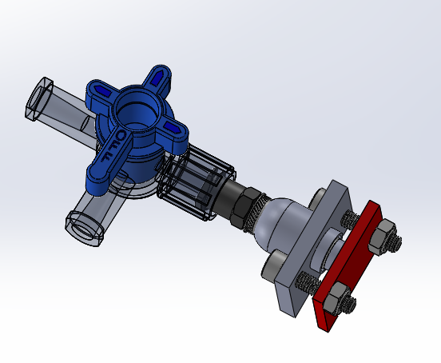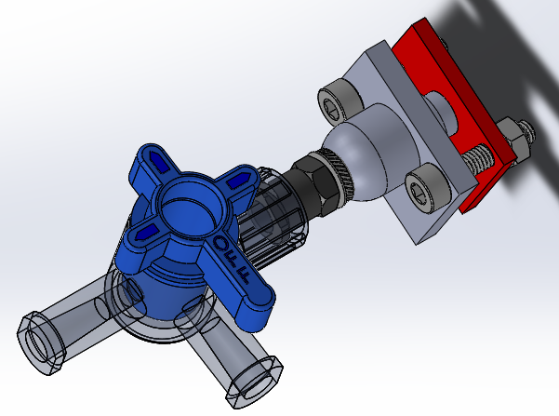

Figure 2: 3-D CAD model of pressure sensor with interfaces to system.

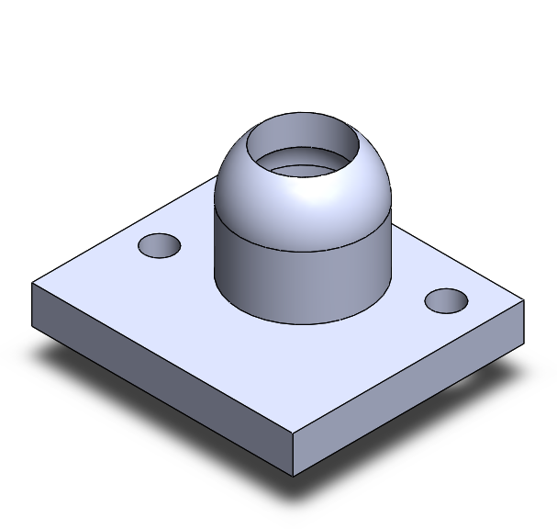

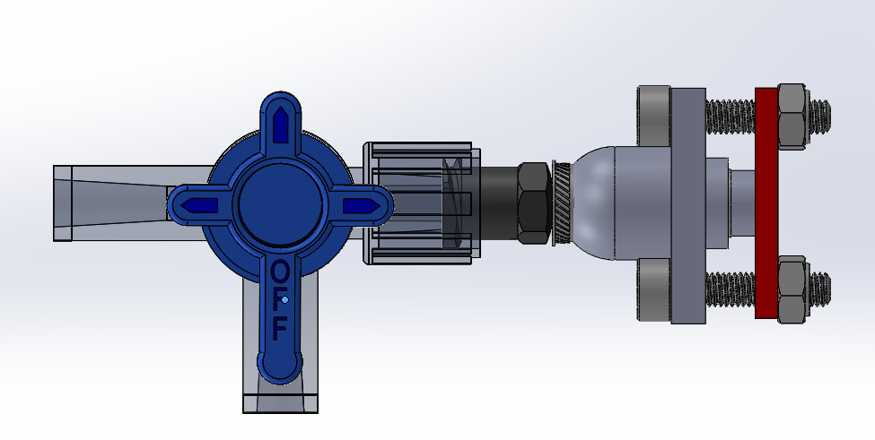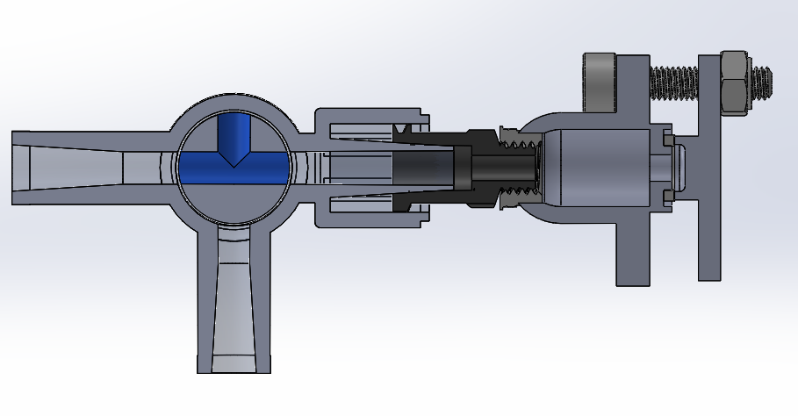

Figure 3: Side view and split view of pressure transducer set up.